*Case Study 1.2:***Insulins suitable for FCL**V.2.2



Full closed looping had been around for a while among some OpenAPS low carb loopers, but picked up momentum from ~ late 2020 when **Lyumjev** was launched.

If the user does not bolus for meals, clearly a very fast insulin is needed so, upon realization of a starting meal-related glucose rise, the loop has any chance to eventually keep glucose in range (by common definition, under 180 mg/dl (10 mmol/l))

In the following we look: 1) Into a mathematical modelling study that explains the implications of “faster” insulins on peak height after various meals and 2) into a comparison a FCL looper did in a thorough study using four different insulins.

1. **General insights from a mathematical modelling study**

A modelling study „The Artificial Pancreas and Meal Control“ by A. El Fathi et al (ref.1) can help us understand the effects on glucose peak heights from the course of carb absorption and of insulin activity. The graph shows on the y axis peak over baseline (the overall deltaBG in mmol/l), and on the x-axis the relative speed of insulin absorption to carb absorption. Carb absorption is always faster, therefore all values are under 1.0. But with Lyumjev we move closer to 1. The model calculation shows that **faster insulins** (red dotted) will result in **lower**

glucose **peaks** than slower insulins (violet dotted: reduction by 46% or minus 2.5 mmol/l =

minus 46 mg/dl after a 60 g carb load).

So, this model supports that using a faster insulin will

* lead to less high glucose peaks, notably for bigger meals
* or might **tolerate** a couple of minutes **delayed** first meal bolus while not incurring unacceptable height of peaks.

The latter is a pre-requisite for full closed loop, in which we leave it up to the loop to notice that a meal „must have started“, and to come forward with SMBs that are typically delayed compared to the bolus as given in hybrid closed loop.

This is an encouraging result.

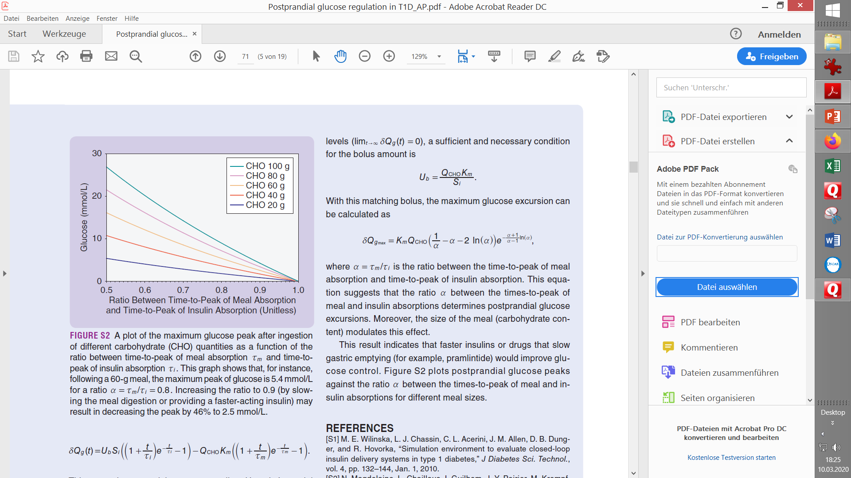

Moreover, the same chart shows us that the spread between the colored curves (they stand for different meal sizes) becomes significantly smaller when we move to the faster insulin with a 0.9 ratio. This means the danger of increasingly high post-meal glucose peaks for high-carb meals is sharply reduced, too. For example, the green curve suggests with the „0.8 insuline“ a peak of 10mmol/l (180 mg/dl) above your glucose level at meal start, but only +4 mmol/l (+70 mg/dl) when using a faster insulin with factor 0.9, which, when starting at or under 110 mg/dl, could keep glucose in range.

The message we can take from this is: **The higher carb loaded our diet, the more important to use the fastest-available insulin.** Using Lyumjev with a 45 minute time-to-peak and 7 h DIA seems a good setting in oref(1) (AAPS).

Some modelling calculations on effect of dialled-in DIA on insulin kinetics were published by szantos @ de.loopercommunity.org May 2022 <https://de.loopercommunity.org/t/naechtlicher-unterzucker/10626> and are reported also in: “Insulins, DIA and other settings.pdf” here: <https://github.com/bernie4375/HCL-Meal-Mgt.-ISF-and-IC-settings/blob/HCL-.-settings-main-repo-(pdf)/Insulins_DIA%20and%20other%20settings_V.2.7.pdf>

Some loopers reported success in full closed loop also using slower insulins; they tend to avoid meal extremes, and/or accept going above range for a brief period more often.

*(ref 1) The Artificial Pancreas and Meal Control. A. El Fathi et al, IEEE Control Systems Magazine Feb.2018 p.67-85. This is a very thorough mathematical modelling study, with 147 references to other literature. However, any modelling must make simplifying assumptions. While our everyday reality is more complex,the authors do carve out, even in quantitative terms, some core mechanisms at play.*

**2. Comparing 4 insulins** (Lyumjev, Fiasp, Apidra, Humalog) **in FCL mode (n=1 study)**

In the following, we look at a study using high carb meals that shows the inferiority of slow insulins, notably of Hunalog, when you attempt to go FCL:

Summary from: [*https://www.facebook.com/download/831505605647892/What%20about%20insulin%20in%20FCL%20mode.pdf*](https://www.facebook.com/download/831505605647892/What%20about%20insulin%20in%20FCL%20mode.pdf) *(Jiri Borek)*

Method

iAPS using Dexcome g6/7, Dash, iPhone (FCL, but not using autoISF)

SMB+UAM FCL mode without any bolus or carb input or TT setting by the user. For one full week with a standardized sequence of meals (150 – 300 g carb/d; and no exercise after meals), the FCL performance was established for each of the 4 insulins trialled: Fiasp 100 ui, Apidra 100 ui, Humalog 200 ui, and Lyumjev 200 ui.

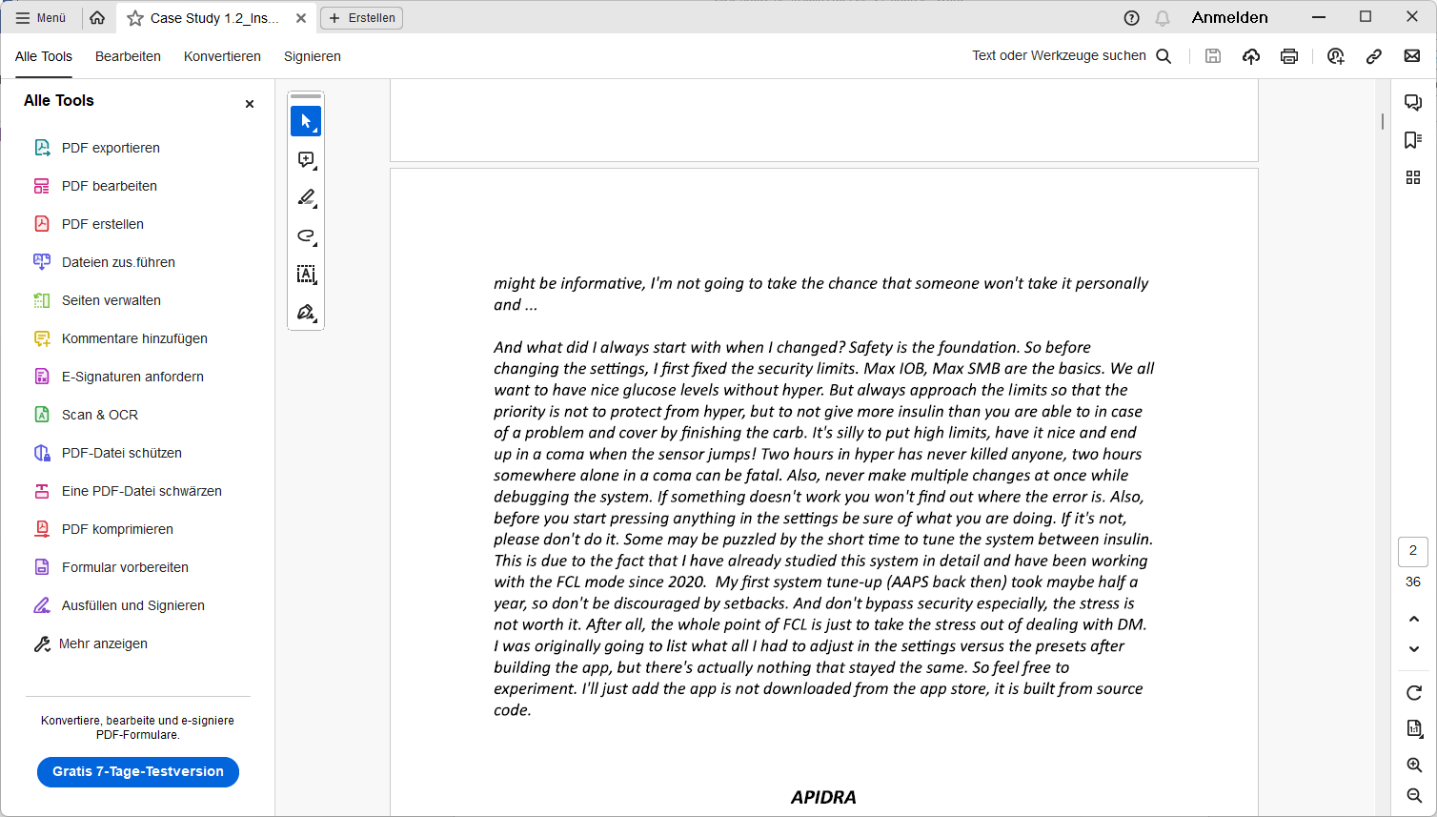

Apidra

What surprised me about Apidra was the pretty quick onset. It managed the glycemia quire successfully. >But – maybe due to ist longer DIA – I had to feed (against) hypoglycemia a few times. 38 values under 3.9 mmol in 1 week (2% of all values are below range) is not terrible, but created a bit of discomfort taking away from the intended ease in FCL.

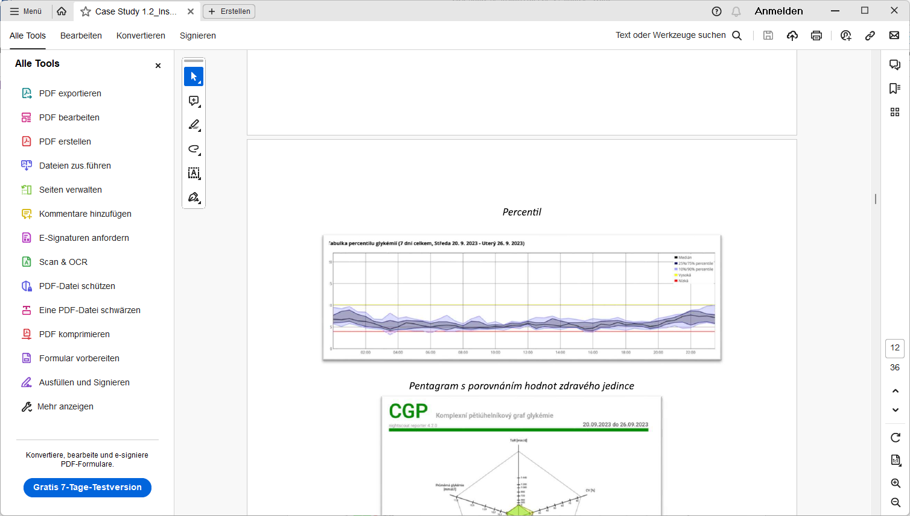

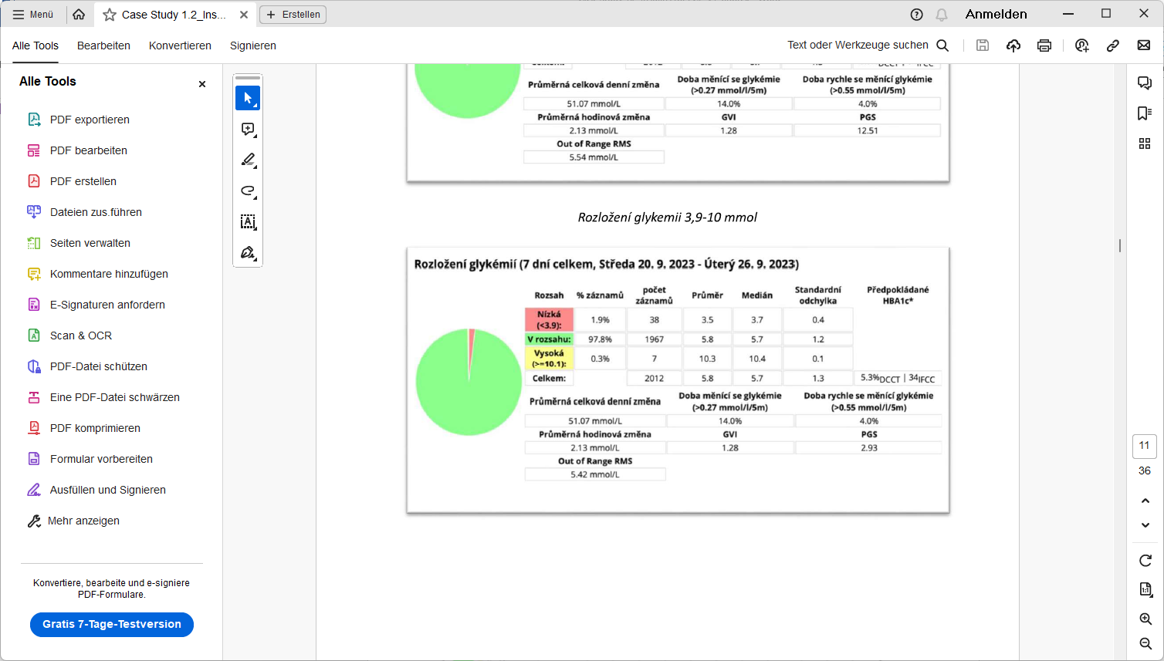

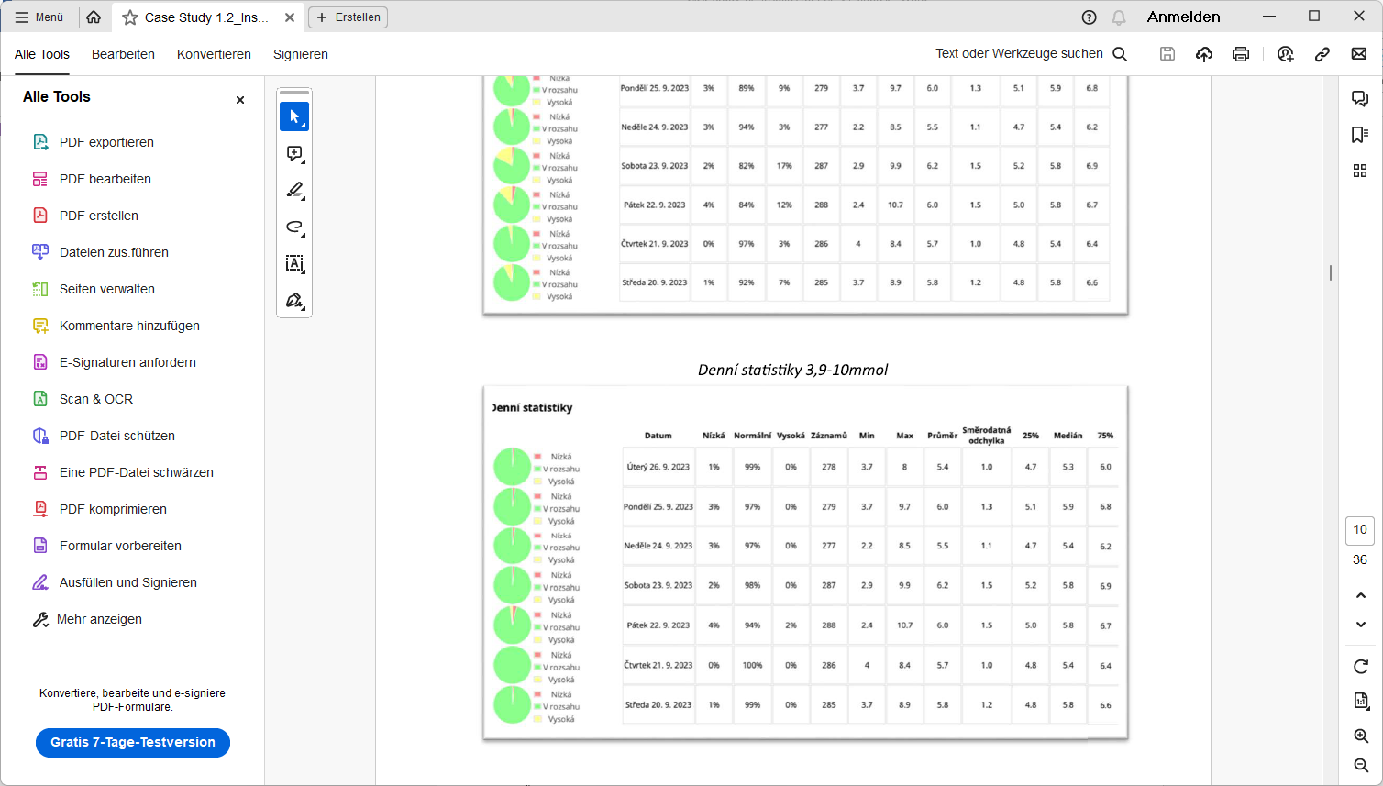

High carb day

Low carb day

Fiasp

I observed some problems also many others have reported, like or tendency towards partial occlusions and elevated insulin need with cannula age. In FCL operation (with regular pod changes, and the typical smaller boli occurring in FCL) overall Fiasp worked well and fairly muchg replicated the good resultzs as was reported for Apidra:

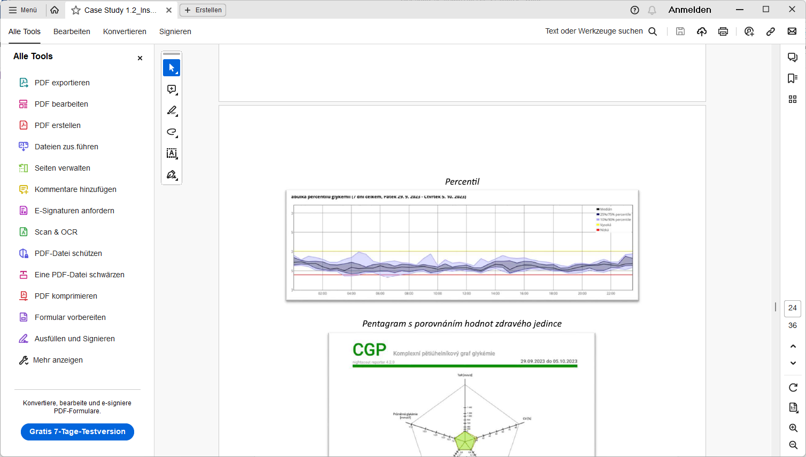

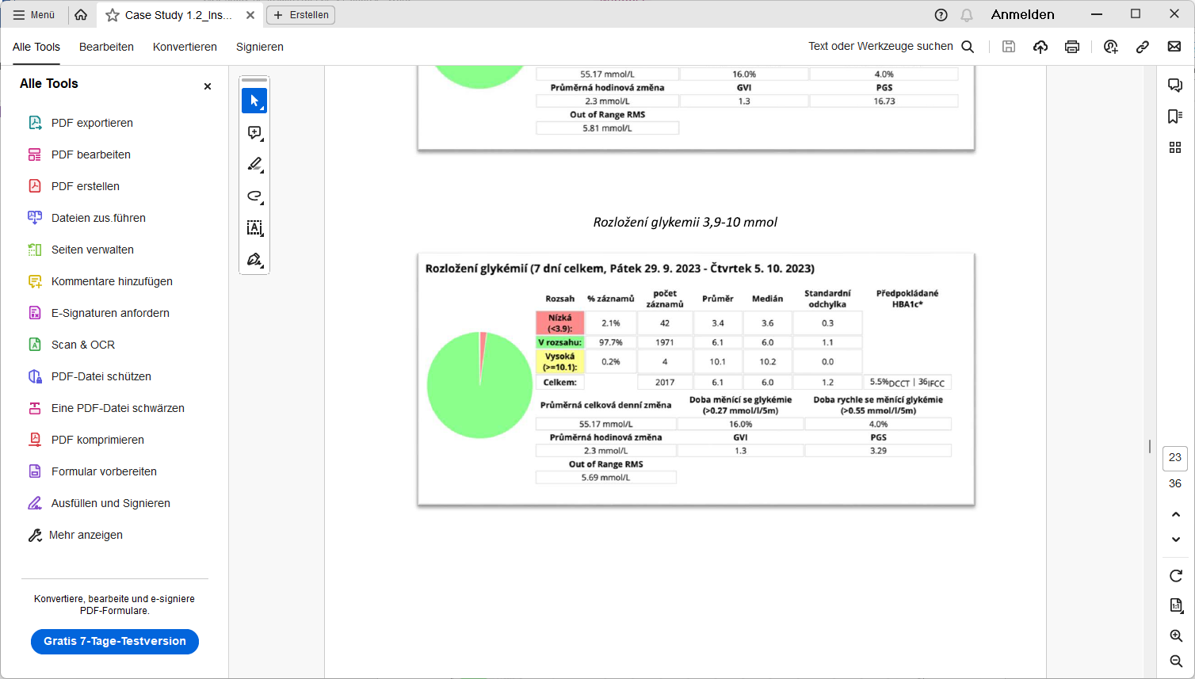

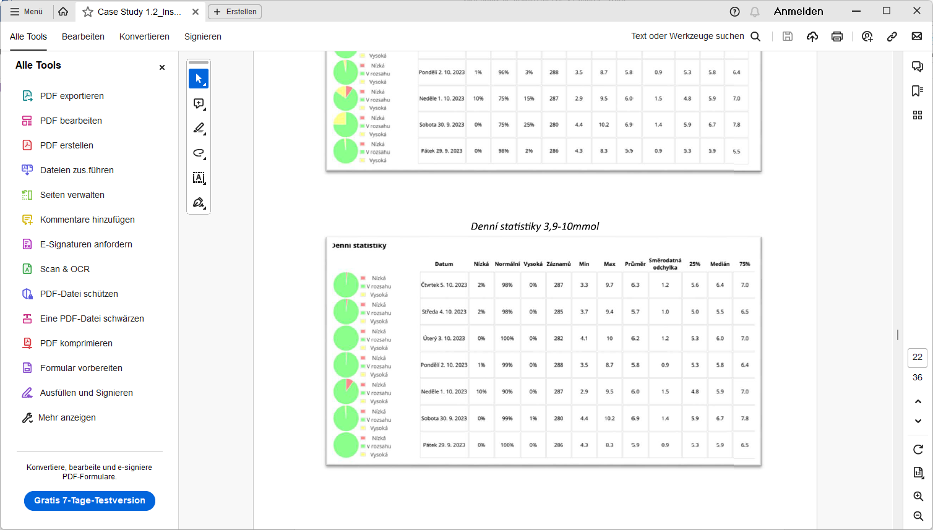

Humalog

Of the tested insulins, it was the

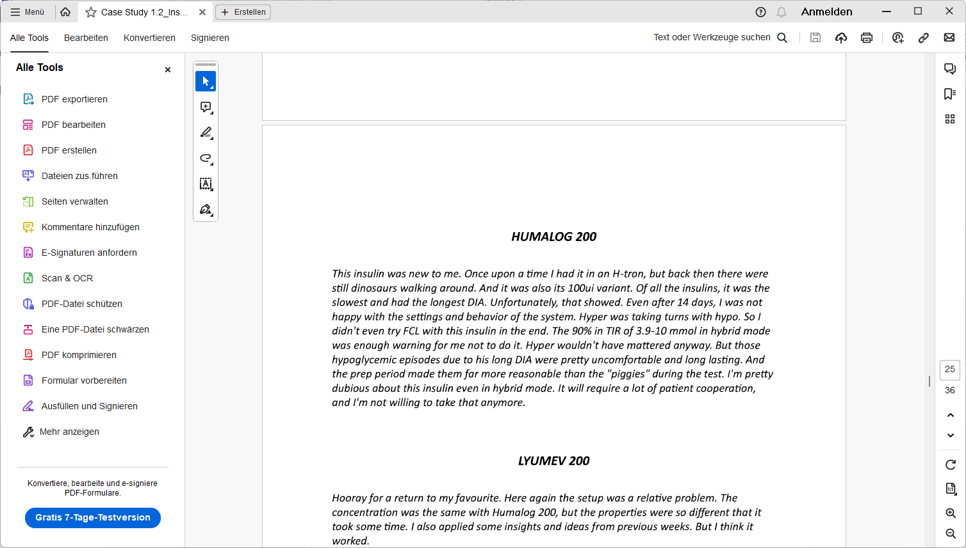

Lyumjev

Lyumjev is the insulin with fastest onset and shortest DIA. At the 3.9-10 mmol TIR level, where I has also with Apidra and Fiasp reached ~97%TIR, the difference was less obvious…

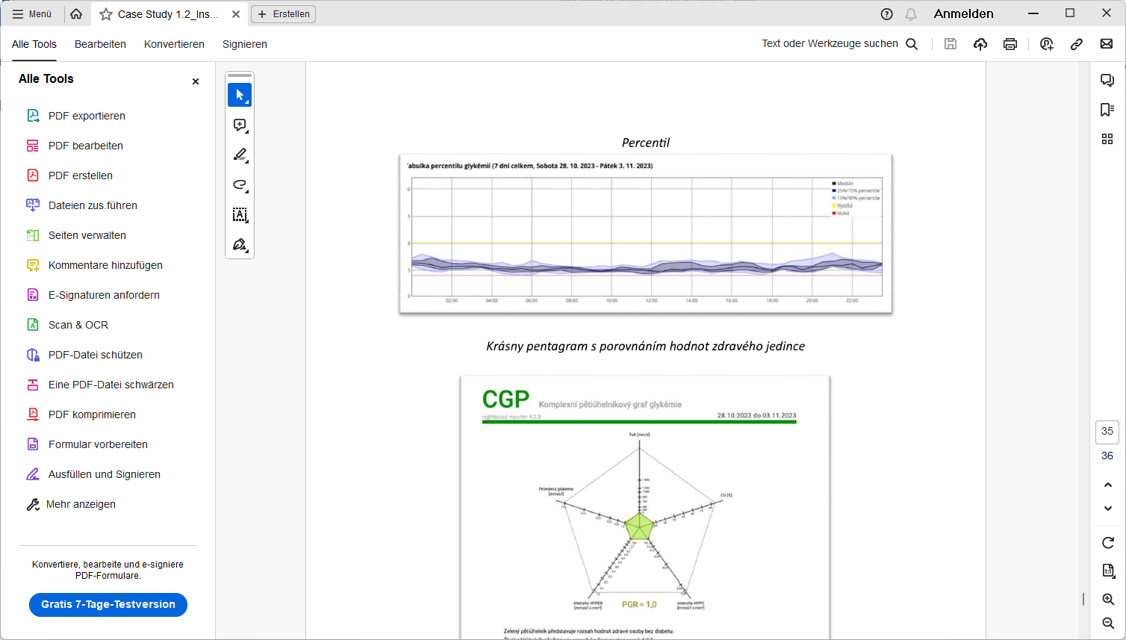

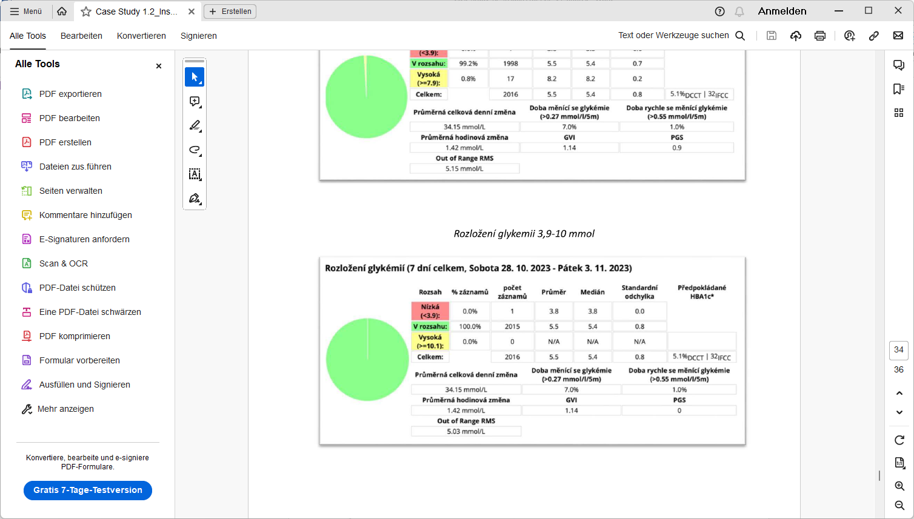

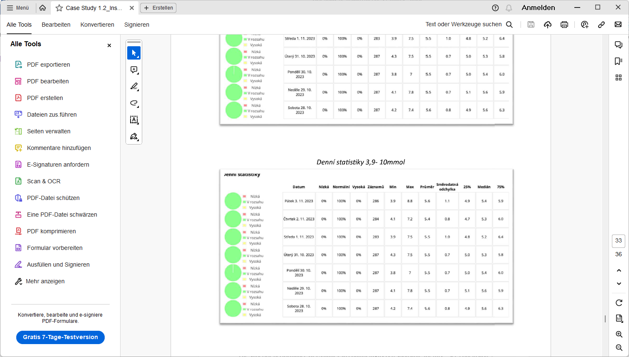

It is very interesting that with Lyumjev I reached the lowest predicted HbA1c (5.1%), despite it coming with a vastly lower incidence of low (0,0% <3.9) values when comparing with Apidra (5.3 % HbA1c @ 1,9% <3.9) and Fiasp (5.5 % HbA1c @ 2,1% <3.9).

The superior performance of Lyumjev to control highs is responsible for this – see conclusion.

Conclusion

**Lyumjev** clearly is the best insulin for my FCL.

* It showed practically no tendency towards hypoglycemia.
* It controlled peaks the best.

This can be best seen when comparing %TIR (3.9 – 7.9 mmol/L)(70-142 mg/dl) between the studied insulins:

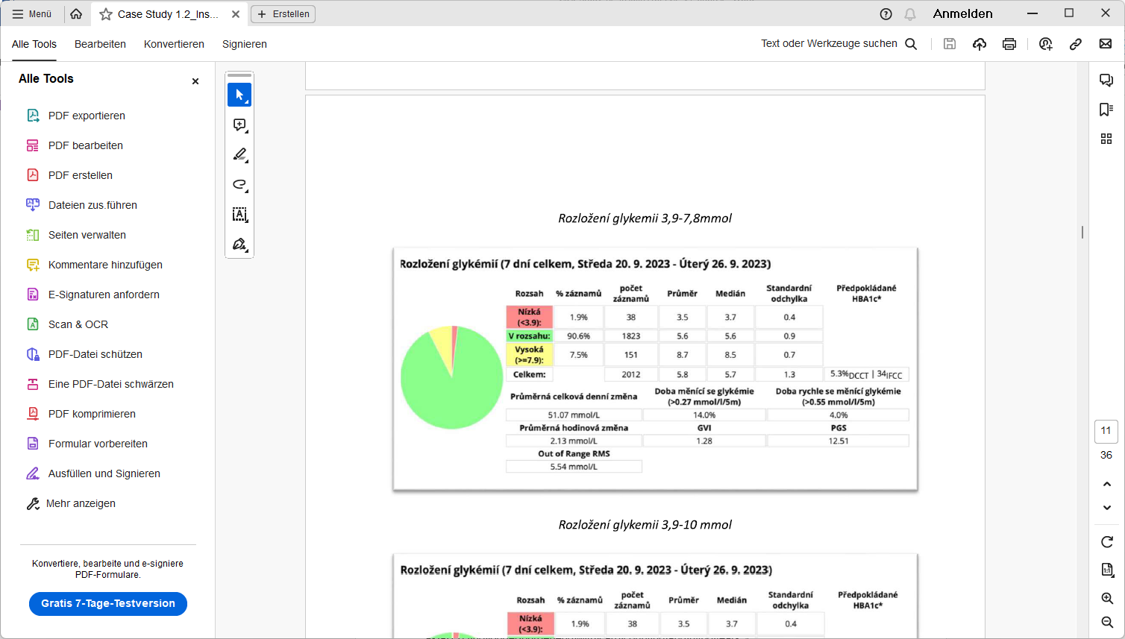 Apidra

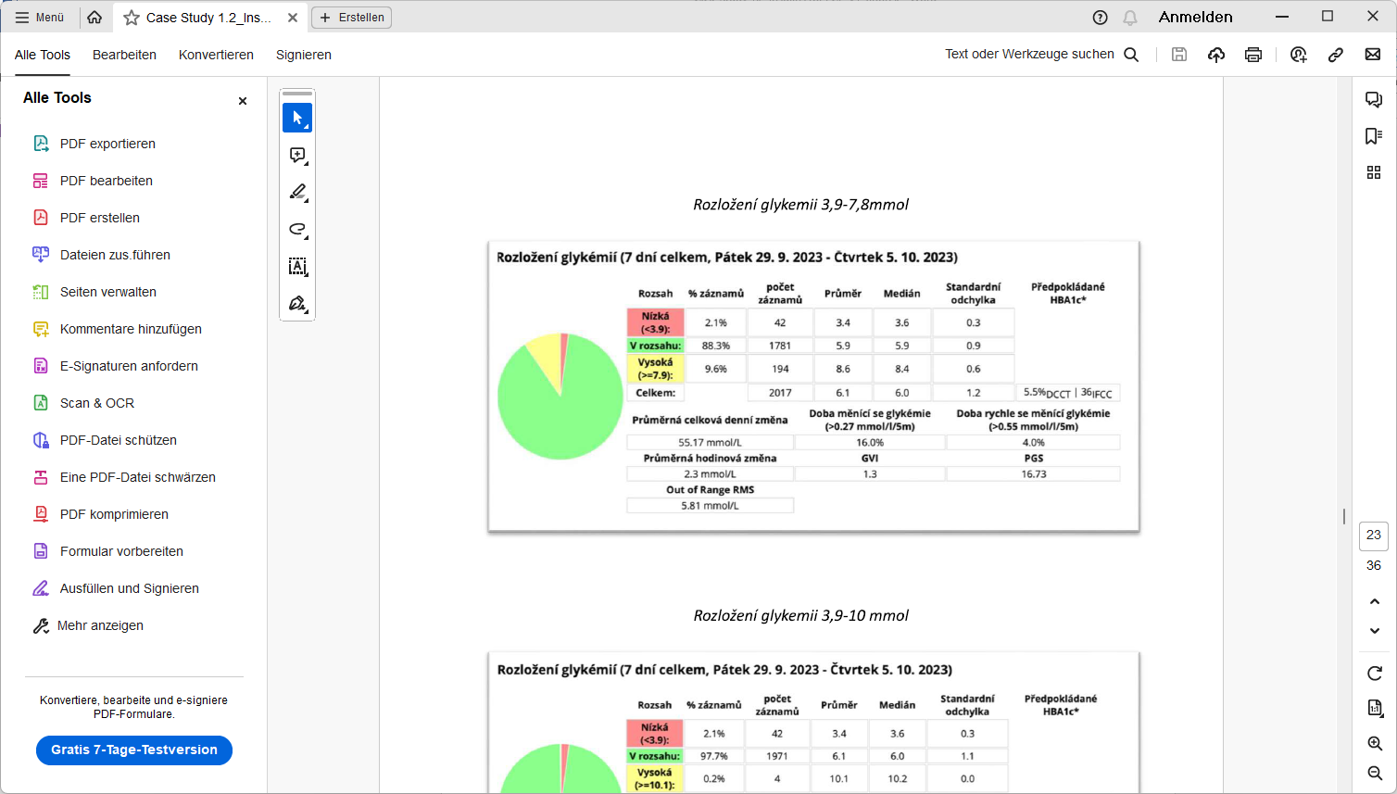Fiasp

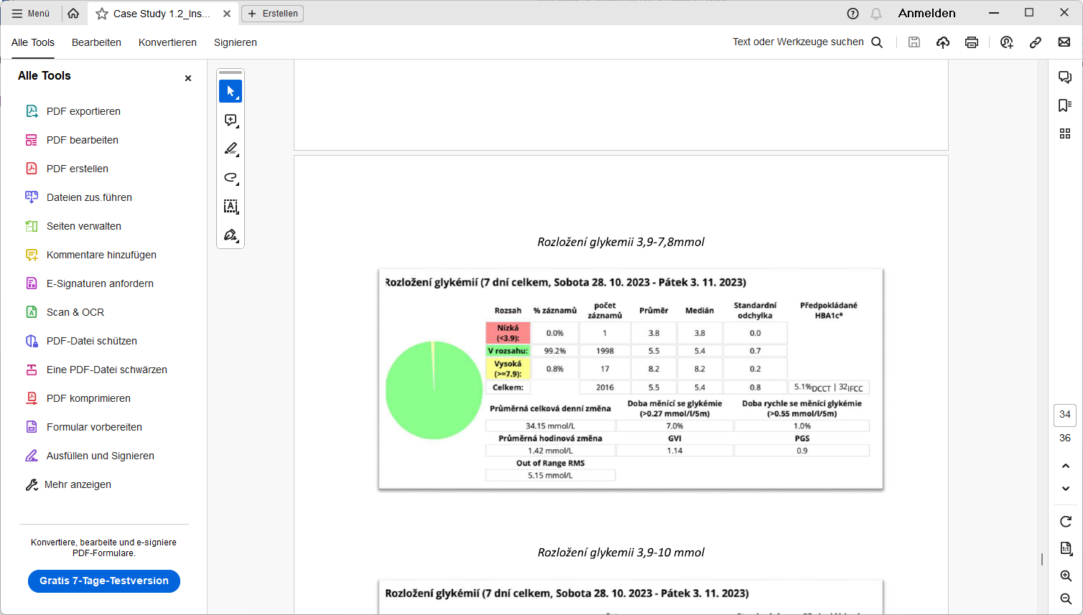 Lyumjev

**Fiasp and Apidra** had about 10 times as many bg values in the elevated range, above 7.9 mmol/L (142 mg/dl).

It is worth noting here again, that the researched range of meals went up to 300 g carb content (which is a „stress test“, way above my usual range).

Loopers on a lower carb diet (and with strong attention to using proper DIA and ISF profile settings) might see FCL viable even using **Humalog**. See e.g. D. Burren <https://bionicwookiee.com/2022/04/13/revised-humalog-model-in-a-closed-loop/> who reports when going Lyumjev to Humalog:

• The TIR for 3.9-7.8 has decreased. 90.3% to 85.1%.

• But the TIR for 3.9-10 has only changed from 97.2% to 97.1%-

*Disclaimer: Above is a report on testing weeks done by an experienced FCL user (FCL with AAPS or iAPS since nearly 3 years). Prior to each testing week, up to 10 days were spent to fine tune settings for the insulin in use. Effects from sickness, strenuous exercise etc. were excluded. Attention to technical system function (CGM performance, Bluetooth stability, timely cannula changes to limit occlusion) was high in these testing weeks, too.*